Documentary
How to Change the World 09 Sep 2015N/A 2015
110 min Biography, Documentary,
IMDB: 7.8/10
287 votes
Jerry Rothwell
Bill Darnell, Bobbi Hunter, David Garrick, Emily Hunter
4 wins & 7 nominations.
Canada, UK 12751
Synopsis
There’s no missing the polemical focuses being made or questioning the film is intended to rouse further activity, however even solidified whale-eating oil oligarchs are prone to be enchanted by the optimism and smarts of these bold activists.

Janis: Little Girl Blue (2015
Janis: Little Girl Blue 15 Dec 2015N/A 2015
103 min Biography, Documentary, HD Movies, Music 7.4
IMDB: 7.4/10
Amy Berg
Cat Power, Janis Joplin, Peter Albin, Sam Andrew
N/A USA 1715
Synopsis
In addition to the concerts, the Doku Janis shows: little girl blue artist off-stage, private as it was. The whole is accompanied heart and cry baby and of Joplin’s letters that she wrote to her family of great songs like piece of my.The native Texan Janis Lyn Joplin sang early in bars in Los Angeles after she taught himself. It resisted the great success just frightening.

Killing Them Safely (2015)
27 Nov 2015N/A 2015
100 min
Documentary, Drama
IMDB: 7.0/10
Nick Berardini
Rick Smith, Tom Smith
1 nomination.
Canada, USA
Synopsis
In the documentary film killing them safely by Nick Berardini is addressed the question, why the methods of the police officers in the United States remain often lead to death innocent people.At the beginning of the 21st century the brothers Tom and Rick Smith, Taser police marketed. It is not unknown that police officers in the United States often use their weapons and people in unnecessarily injure or even kill.

Finders Keepers (2015)
25 Sep 2015R 2015
82 min
Documentary,
IMDB: 7.2/10
Bryan Carberry, J. Clay TweelJohn Wood, Shannon Whisnant
2 wins & 1 nomination.
USA
Synopsis
After separating the road from where he had moved with his wife by taking the daughter of a woman who decided to stay away from him. He moved to a house in which they live quite far away from home when her mother began to settle home while baby girl finds a home.

Addicted to Sexting (2015)
17 Nov 2015
80 min
Documentary, HD Movies, Romance
IMDB: 5.7/10
Joseph Tosconi
N/A USA
Synopsis
Zoe, a good job , a good career , a wonderful husband, a woman who believes that a perfect life with his beloved two children and a mother who always stood by his life . After talks with one of the clients represented by the fact that life , the difference is between a number of shortcomings with her husband.

Why I’m Not on Facebook (2014)
Why I'm Not on Facebook
03 Nov 2015
78 min
Comedy, Documentary, Family
IMDB: 7.0/10
Brant Pinvidic
N/A Canada, USA

Synopsis
I’m on Facebook. You’re on Facebook. Jesus is on Facebook. Indeed, even dead individuals are on Facebook. Maybe the main individual who isn’t is Brant Pinvidic, who clarifies the purposes behind his not joining the world’s most prominent long range informal communication site in his meandering narrative.

For Grace (2015)
13 Mar 2015
92 min
Biography, Documentary, Family
IMDB: 7.9/10
Kevin Pang, Mark Helenowski
Curtis Duffy
1 win & 1 nomination.
USA

Synopsis
Up to a specific point in “For Grace,” Kevin Pang and Mark foodie-driven narrative around a Chicago culinary expert’s journey to open and work the eatery he had always wanted, groups of onlookers are liable to be more dazed than moved by the determined fixation of its seriously determined subject.

Tell Spring Not to Come This Year (2015)
13 Nov 2015
84 min
Documentary, War
IMDB: 7.2/10 135
Michael McEvoy, Saeed Taji Farouky
3 wins & 5 nominations.
UK, Afghanistan

Synopsis
With the withdrawal of NATO forces from Afghanistan the Afghan acquires National Army (ANA) control in Helmand province, which is considered to be extremely dangerous. Attacks by Taliban fighters are the order of the day. Security or even peace seem out of reach, already a common language that is difficult in a country in which everyone distrusts everyone.

Theatrical release poster
Directed by Álex de la Iglesia
Written by Jorge Valdano
Lionel Messi Andrés Iniesta Gerard Piqué Jorge Valdano Johan Cruyff César Luis Menotti Jamal January 1, 2015
93 minutes
Synopsis
The film focuses on Argentine footballer Lionel Messi, from his youth in Rosario to becoming one of the world's greatest players at Barcelona, and features Jorge Valdano discussing the qualities of Messi with Barcelona legend Johan Cruyff and former Argentina manager César Luis Menotti. In making the film, Iglesia said he was influenced by Orson Welles' Citizen Kane and Woody Allen's Broadway Danny Rose.[4] The film was produced by Mediapro and distributed by Film Factory.

Country: UK | Kosovo
Release Date: 10 April 2015 (USA)
Filming Locations: Mitrovica, Kosovo
Company Credits

Production Co: Eagle Eye Media
Runtime: 21 min
Director: Jamie Donoughue
Writers: Jamie Donoughue, Jamie Donoughue
Stars: Fisnik Ademi, Aurita Agushi, Andi Bajgora

Synopsis
This movie just makes you appreciate life and how we all should fight for our freedom. Serbs committed ethnic cleansing against Albanians throughout the 1980s-1999s. For the people that don't know much about Kosovo, here is some background information: Albania which included Kosovo was divided in 1914, but Serbia did not gain full control of Kosovo until 1940s. But to fully take the land, they had to eliminate the Albanians who were living there.To do so, they distroyed the Albanian Kosovo history and filled it with Serbian propaganda. Then Serbs started to be ruthless and committed genocide in the Balkan region, this movie is just a glimpse of the nightmare Albanians had to face in their own land.

Drama:

Alex Garland, writer of 28 Days Later and Sunshine, makes his directorial debut with the stylish and cerebral thriller, EX MACHINA. Caleb Smith (Domhnall Gleeson), a programmer at an internet-search giant, wins a competition to spend a week at the private mountain estate of the company's brilliant and reclusive CEO, Nathan Bateman (Oscar Isaac).
Starring: Domhnall Gleeson, Corey Johnson Runtime: 1 hour, 48 minutes
Available to watch on supported devices.

Genres Science Fiction, Drama, Thriller, Mystery
Director Alex Garland
Starring Domhnall Gleeson, Corey Johnson
Supporting actors Oscar Isaac, Alicia Vikander, Sonoya Mizuno, Claire Selby, Symara A. Templeman, Gana Bayarsaikhan, Tiffany Pisani, Elina Alminas, Chelsea Li, Ramzan Miah, Caitlin Morton, Deborah Rosan, Johanna Thea, Evie Wray

Sex. Money. Power. Drugs. Brace yourself for an outrageous true story from legendary filmmaker Martin Scorsese. Leonardo DiCaprio stars as a young stockbroker hungry for a life of non-stop thrills, where corruption was king and more was never enough.
Starring: Leonardo DiCaprio, Jonah Hill Runtime: 2 hours, 59 minutes
Available to watch on supported devices.
Genres Drama, Comedy
Director Martin Scorsese
Starring Leonardo DiCaprio, Jonah Hill
Supporting actors Margot Robbie, Matthew McConaughey, Kyle Chandler, Rob Reiner, Jon Bernthal

THE KINGS OF SUMMER follows three teenage boys (Robinson, Basso and Arias) as they head into the wilderness with a plan to build a house and live off the land.
Starring: Nick Robinson, Gabriel Basso Runtime: 1 hour, 34 minutes
Genres Drama, Adventure, Comedy
Director Jordan Vogt-Roberts
Starring Nick Robinson, Gabriel Basso
Supporting actors Moises Arias, Nick Offerman, Erin Moriarty, Craig Cackowski, William Sonnie

George Lopez leads a winning cast in this inspiring true story about four high-school students who defy the odds in a competition against the nation's top universities.
Starring: George Lopez, Marisa Tomei Runtime: 1 hour, 54 minutes
Genres Drama
Director Sean McNamara
Starring George Lopez, Marisa Tomei
Supporting actors Jamie Lee Curtis, Carlos PenaVega, José Julián, David Del Rio

From the producers of THE KING'S SPEECH comes the feature film adaptation of Shakespeare's play MACBETH about Scottish General Macbeth (Michael Fassbender) whose ambitious wife (Marion Cotillard) urges him to use wicked means in order to gain power of the throne over the sitting king.
Starring: Michael Fassbender, Marion Cotillard Runtime: 1 hour, 53 minutes
Genres Drama
Director Justin Kurzel
Starring Michael Fassbender, Marion Cotillard
Supporting actors Paddy Considine, David Thwelis, Sean Harris, Jack Reynor

Set in ancient Egypt under Roman rule, AGORA follows the brilliant and beautiful astronomer Hypatia (Weisz) who leads a group of disciples fighting to save the wisdom of the Ancient World.
Starring: Rachel Weisz, Max Minghella Runtime: 2 hours, 6 minutes
Genres Drama, Romance, Adventure
Director Alejandro Amenábar
Starring Rachel Weisz, Max Minghella
Supporting actors Oscar Isaac, Ashraf Barhom, Michael Lonsdale, Rupert Evans, Homayoun Ershadi, Sami Samir

When Carol (Blythe Danner) seeks out new experiences with the help of friends (June Squibb, Rhea Perlman and Mary Kay Place), she unexpectedly finds romance (Sam Elliot).
Starring: Blythe Danner, Martin Starr Runtime: 1 hour, 36 minutes
Genres Drama, Romance, Comedy
Director Brett Haley
Starring Blythe Danner, Martin Starr
Supporting actors June Squibb, Rhea Perlman, Mary Kay Place, Malin Akerman, Sam Elliott

There's the right way, the wrong way and the Army way. But there's no way military investigator Paul Brenner (John Travolta) is going to participate in a cover-up when Fort MacCallum officials try to hide the motive behind the murder of a beautiful female officer.
Starring: John Travolta, Madeleine Stowe Runtime: 1 hour, 56 minutes
Genres Drama, Thriller, Mystery
Director Simon West
Starring John Travolta, Madeleine Stowe
Supporting actors James Cromwell, Timothy Hutton, Leslie Stefanson, Daniel von Bargen

"Ferrell has never been better" (Playboy) as a salesman who loses his wife and his job in the same day and, faced with his life imploding, begins living on his front lawn.
Starring: Will Ferrell, Christopher Jordan Wallace Runtime: 1 hour, 37 minutes
Genres Drama, Comedy
Director Dan Rush
Starring Will Ferrell, Christopher Jordan Wallace
Supporting actors Rebecca Hall, Michael Peña, Rosalie Michaels, Stephen Root

From the best selling book by Gillian Flynn (Gone Girl), Charlize Theron stars in this acclaimed thriller about a woman investigating a family murder with the help of a secret society obsessed with solving notorious crimes.
Starring: Charlize Theron, Sterling Jerins Runtime: 1 hour, 53 minutes
Genres Drama, Thriller, Mystery
Director Gilles Paquet-Brenner
Starring Charlize Theron, Sterling Jerins
Supporting actors Nicholas Hoult, Christina Hendricks, Corey Stoll, Tye Sheridan

Horror

While attending a dinner party at his former home, a man thinks his ex-wife and her new husband have sinister intentions for their guests.
Director: Karyn Kusama
Writers: Phil Hay (screenplay), Matt Manfredi (screenplay)
Stars: Logan Marshall-Green, Emayatzy Corinealdi, Michiel Huisman
The Buzz: The indie world is happy to see Girlfight director Karyn Kusama back in genre mode. Joining her is the screenwriting duo of Phil Hay and Matt Manfredi, who worked with Kusama on both Crazy/Beautiful and Æon Flux.

10 Cloverfield Lane (2016)
103 min - Drama | Horror | Mystery | Sci-Fi | Thriller
7.7/10
Metascore: 76/100
After getting in a car accident, a woman is held in a shelter with two men, who claim the outside world is affected by a widespread chemical attack.
Director:
Dan Trachtenberg
Stars:
John Goodman, Mary Elizabeth Winstead, John Gallagher Jr., Douglas M. Griffin

Green Room (2015)
94 min - | Horror | Thriller
Metascore: 80/100
After witnessing a murder, a punk rock band is forced into a vicious fight for survival against a group of maniacal skinheads.
Director:
Jeremy Saulnier
Stars:
Anton Yelchin, Imogen Poots, Alia Shawkat, Patrick Stewart

Tale of Tales (2015)
15 125 min - Fantasy | Horror | Romance
Metascore: 80/100 (10 reviews)
The film serves as Garrone's English-language debut and will interweave three separate story strands bookended by brief bits in which Italians Alba Rohrwacher and Massimo Ceccherini will play a street circus family. In one tale Salma Hayek will play a jealous queen who forfeits her husband's life. In another, Vincent Cassel plays a king whose passion is stoked by two mysterious sisters.
Director:
Matteo Garrone
Stars:
Salma Hayek, Vincent Cassel, Toby Jones, John C. Reilly

The Conjuring 2 (2016)
Horror
Lorraine and Ed Warren travel to north London to help a single mother raising four children alone in a house plagued by malicious spirits.
Director:
James Wan
Stars:
Vera Farmiga, Patrick Wilson, Franka Potente, Frances O'Connor

The Purge: Election Year (2016)
Action | Horror | Sci-Fi | Thriller
Two years after choosing not to kill the man who killed his son, former police sergeant Barnes has become head of security for Senator Charlene Roan, the front runner in the next Presidential election due to her vow to eliminate the Purge.
Director:
James DeMonaco
Stars:
Elizabeth Mitchell, Frank Grillo, Mykelti Williamson, Ethan Phillips

Don't Breathe (2016)
Horror | Thriller
A group of teens break into a blind man's home thinking they'll get away with the perfect crime. They're wrong.
Director:
Fede Alvarez
Stars:
Jane Levy, Dylan Minnette, Stephen Lang, Daniel Zovatto

Lights Out (2016)
Horror
A woman is haunted by a creature that only appears when the lights go out. A feature adaptation of the 2013 short film, "Lights Out" by David Sandberg.
Director:
David F. Sandberg
Stars:
Teresa Palmer, Maria Bello, Alicia Vela-Bailey, Billy Burke

The Dark Tower (2017)
Fantasy | Horror | Sci-Fi | Western
Gunslinger Roland Deschain roams an Old West-like landscape in search of the dark tower, in the hopes that reaching it will preserve his dying world.
Director:
Nikolaj Arcel
Stars:
Idris Elba, Matthew McConaughey, Abbey Lee, Tom Taylor

The Other Side of the Door (2016)
96 min - Horror
Metascore: 41/100 (10 reviews)
After her young son is killed in a tragic accident, a woman learns of a ritual which will bring him back to say goodbye, but when she disobeys a sacred warning, she upsets the balance between life and death.
Director:
Johannes Roberts
Stars:
Sarah Wayne Callies, Jeremy Sisto, Sofia Rosinsky, Logan Creran

The Forest (2016)
93 min - Horror | Mystery | Thriller
Metascore: 34/100 (30 reviews)
A woman goes into Japan's Suicide Forest to find her twin sister, and confronts supernatural terror.
Director:
Jason Zada
Stars:
Natalie Dormer, Eoin Macken, Stephanie Vogt, Osamu Tanpopo
The Buzz: The Aokigahara forest is an unsettling environment worthy of a psychological horror movie, and I'm looking forward to watching Natalie Dormer navigate a terrain worlds away from Westeros. Here's hoping the screenplay will have some humanity, too. - Arno Kazarian
Romance

A Royal Night Out (2015)
97 min - Comedy | Drama | Romance
Metascore: 58/100 (17 reviews)
On V.E. Day in 1945, as peace extends across Europe, Princesses Elizabeth and Margaret are allowed out to join the celebrations. It is a night full of excitement, danger and the first flutters of romance.
Director:
Julian Jarrold
Stars:
Sarah Gadon, Bel Powley, Emily Watson, Rupert Everett
The Buzz: Underrated director Julian Jarrold has assembled one of the more appealing casts of the year for what seems to be a feather-light but imminently watchable slice of royal-girl fantasy. congratulations to star Bel Powley for her breakout year with The Diary of a Teenage Girl, a performance for which she just won a Gotham Award.

45 Years (2015)
95 min - Drama | Romance
Metascore: 94/100
A married couple preparing to celebrate their wedding anniversary receives shattering news that promises to forever change the course of their lives.
Director:
Andrew Haigh
Stars:
Charlotte Rampling, Tom Courtenay, Geraldine James, Dolly Wells
The Buzz: Love that Andrew Haigh follows up his Weekend with another relationship drama, and I understand 45 Years begins with a gun shot and then rewinds the narrative as long-married couple's history unravels when an incident from one of their pasts resurfaces. Charlotte Rampling and Tom Courtenay were awarded Best Actress/Best Actor trophies at the Berlin International Film Festival earlier this year, and both performers have been tipped for potential Oscar nominations. - Arno

Brooklyn (2015)
111 min - Drama | Romance
Metascore: 87/100 (42 reviews)
An Irish immigrant lands in 1950s Brooklyn, where she quickly falls into a romance with a local. When her past catches up with her, however, she must choose between two countries and the lives that exist within.
Director:
John Crowley
Stars:
Saoirse Ronan, Emory Cohen, Domhnall Gleeson, Jim Broadbent
The Buzz: Seems like Carol isn't the only melodrama on the awards scene this season, as John Crowley's immigrant tale has earned strong reviews for its nods to all things America circa 1950. If there were a Oscar for Best Casting, it appears as though Fiona Ware -- who also cast Room and Suffragette -- would earn the award for the movie's letter-perfect performances.

Miss You Already (2015)
112 min - Comedy | Drama | Romance
Metascore: 59/100 (24 reviews)
The friendship between two life-long girlfriends is put to the test when one starts a family and the other falls ill.
Director:
Catherine Hardwicke
Stars:
Drew Barrymore, Toni Collette, Dominic Cooper, Paddy Considine
The Buzz: With all the discussion about the desire for increased visibility of women in lead roles in the movies, it's disheartening to read Miss You Already's reviews, most of which indicate that neither the material nor the two lovable stars are able to bring much to this story of female friendship.

Prem Ratan Dhan Payo (2015)
164 min - Action | Drama | Romance
While recovering from an assassination attempt four days before his coronation, a stern prince is replaced by a heartfelt lookalike.
Director:
Sooraj R. Barjatya
Stars:
Salman Khan, Sonam Kapoor, Anupam Kher, Neil Nitin Mukesh
The Buzz: There's a somber shadow over Diwali this year, so we're unsure how this romantic drama will perform at the Indian and worldwide box office, but the reunion of Salman Khan and Sonam Kapoor for director Sooraj Barjatya (who gave Khan one of his earliest roles) might bring some added warmth to the holiday.

Carol (2015)
118 min - Drama | Romance
Metascore: 95/100
An aspiring photographer develops an intimate relationship with an older woman.
Director:
Todd Haynes
Stars:
Cate Blanchett, Rooney Mara, Sarah Paulson, Kyle Chandler
The Buzz: The amount of time that passes between Todd Haynes projects is always frustrating for his fans, but his latest film, an adaptation of a novel by Patricia Highsmith - if only they had collaborated while she was still alive! - has left us in breathless anticipation of what's been called a peerless performance by Cate Blanchett. - Arno

The Danish Girl (2015)
119 min - Biography | Drama | Romance
Metascore: 66/100 (40 reviews)
A fictitious love story loosely inspired by the lives of Danish artists Lili Elbe and Gerda Wegener. Lili and Gerda's marriage and work evolve as they navigate Lili's groundbreaking journey as a transgender pioneer.
Director:
Tom Hooper
Stars:
Eddie Redmayne, Alicia Vikander, Amber Heard, Ben Whishaw

Freeheld (2015)
103 min - Biography | Drama | Romance
Metascore: 50/100 (30 reviews)
New Jersey police lieutenant, Laurel Hester, and her registered domestic partner, Stacie Andree, both battle to secure Hester's pension benefits when she is diagnosed with terminal cancer.
Director:
Peter Sollett
Stars:
Julianne Moore, Ellen Page, Steve Carell, Michael Shannon

Big Stone Gap (2014)
143 min - Comedy | Romance
Metascore: 39/100
In a small town nestled in the Appalachian Mountains of Virginia, self-proclaimed spinster Ave Maria Mulligan finds her life shaken up and forever changed after learning a long-buried family secret.
Director:
Adriana Trigiani
Stars:
Ashley Judd, Patrick Wilson, Whoopi Goldberg, John Benjamin Hickey

Before We Go (2014)
95 min - Comedy | Drama | Romance
Metascore: 31/100 (10 reviews)
Two strangers stuck in Manhattan for the night grow into each other's most trusted confidants when an evening of unexpected adventure forces them to confront their fears and take control of their lives.
Director:Chris Evans
Stars:Chris Evans, Alice Eve, Emma Fitzpatrick, Scott Evans
The Buzz: Chris Evans's directorial debut has done well on VOD already, so this theatrical release is a bonus for him and the studio; perhaps he'll find time between his Captain America duties for a second movie?
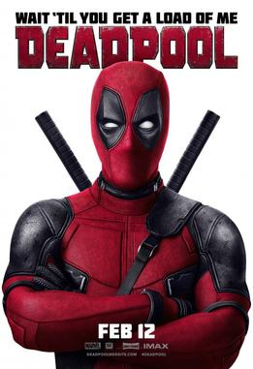

Deadpool
February 12, 2016
108 mins
United States
Tim Miller
Ryan Reynolds
Morena Baccarin
Ed Skrein
T. J. Miller
Action
189sek
A former Special Forces operative turned mercenary is subjected to a rogue experiment that leaves him with accelerated healing powers, adopting the alterego Deadpool.

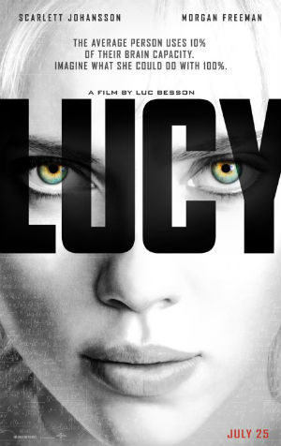
Lucy
July 25, 2014
90 mins
France
United States
Luc Besson
Scarlett Johansson
Morgan Freeman
Choi Min-sik
Amr Waked
Action
99sek
A woman, accidentally caught in a dark deal, turns the tables on her captors and transforms into a merciless warrior evolved beyond human logic.

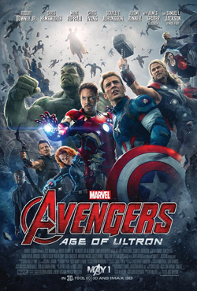
Avengers: Age of Ultron
May 1, 2015
141 mins
United States
Joss Whedon
Robert Downey Jr.
Chris Hemsworth
Mark Ruffalo
Chris Evans
Action
179sek
When Tony Stark and Bruce Banner try to jump-start a dormant peacekeeping program called Ultron, things go horribly wrong and it's up to Earth's Mightiest Heroes to stop the villainous Ultron from enacting his terrible plans.

Jurassic World
June 12, 2015
124 mins
United States
Colin Trevorrow
Chris Pratt
Bryce Dallas Howard
Vincent D'Onofrio
Ty Simpkins
Action
149sek
A new theme park is built on the original site of Jurassic Park. Everything is going well until the park's newest attraction--a genetically modified giant stealth killing machine--escapes containment and goes on a killing spree.
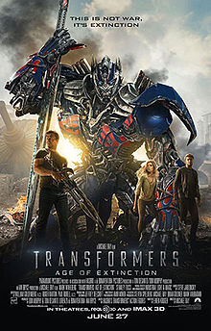
Transformers: Age of Extinction
June 27, 2014
165 mins
United States
China
Michael Bay
Mark Wahlberg
Stanley Tucci
Action
139sek
Autobots must escape sight from a bounty hunter who has taken control of the human serendipity: Unexpectedly, Optimus Prime and his remaining gang turn to a mechanic, his daughter, and her back street racing boyfriend for help.
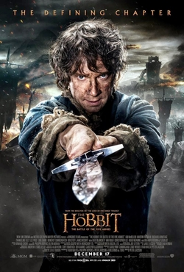
The Hobbit: The Battle of the Five Armies
December 17, 2014
164 mins
New Zealand
United States
Peter Jackson
Martin Freeman
Ian McKellen
Richard Armitage
Evangeline Lilly
Action
Drama
159sek
Bilbo and Company are forced to engage in a war against an array of combatants and keep the Lonely Mountain from falling into the hands of a rising darkness.
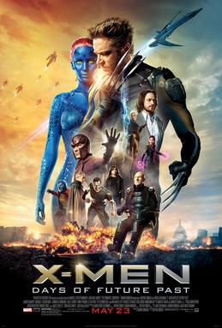
X-Men: Days of Future Past
May 23, 2014
131 mins
United States
Bryan Singer
Hugh Jackman
James McAvoy
Michael Fassbender
Jennifer Lawrence
Action
129sek
The X-Men send Wolverine to the past in a desperate effort to change history and prevent an event that results in doom for both humans and mutants.
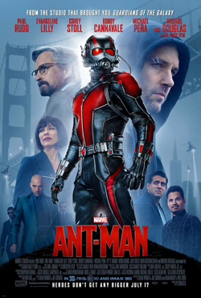
Ant-Man
July 17, 2015
117 mins
United States
Peyton Reed
Paul Rudd
Evangeline Lilly
Corey Stoll
Bobby Cannavale
Action
179sek
Armed with a super-suit with the astonishing ability to shrink in scale but increase in strength, cat burglar Scott Lang must embrace his inner hero and help his mentor, Dr. Hank Pym, plan and pull off a heist that will save the world.
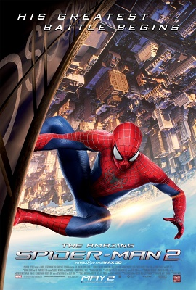
The Amazing Spider-Man 2
May 2, 2014
142 mins
United States
Marc Webb
Andrew Garfield
Emma Stone
Jamie Foxx
Dane DeHaan
Action
89sek
When New York is put under siege by Oscorp, it is up to Spider-Man to save the city he swore to protect as well as his loved ones.

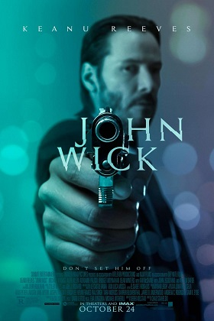
John Wick
October 24, 2014
101 mins
United States
Chad Stahelski
David Leitch
Keanu Reeves
Michael Nyqvist
Alfie Allen
Adrianne Palicki
Action
Crime
99sek
An ex-hitman comes out of retirement to track down the gangsters that took everything from him.
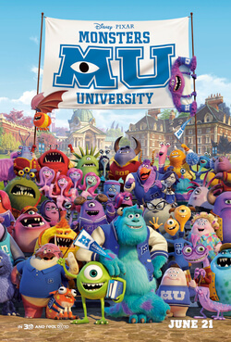
Monsters University
June 21, 2013
104 mins
United States
Dan Scanlon
Billy Crystal
John Goodman
Steve Buscemi
Helen Mirren
Cartoon
199sek
A look at the relationship between Mike and Sulley during their days at Monsters University -- when they weren't necessarily the best of friends.
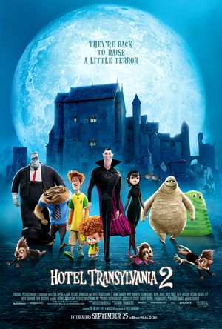
Hotel Transylvania 2
September 25, 2015
89 mins
United States
Genndy Tartakovsky
Adam Sandler
Andy Samberg
Selena Gomez
Kevin James
Cartoon
129sek
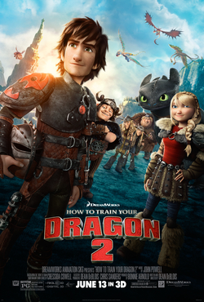
Dracula and his friends try to bring out the monster in his half human, half vampire grandson in order to keep Mavis from leaving the hotel.
How to Train Your Dragon 2
June 13, 2014
102 mins
United States
Dean DeBlois
Jay Baruchel
Cate Blanchett
Gerard Butler
Craig Ferguson
Cartoon
99sek
When Hiccup and Toothless discover an ice cave that is home to hundreds of new wild dragons and the mysterious Dragon Rider, the two friends find themselves at the center of a battle to protect the peace.

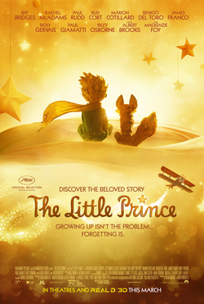
The Little Prince
29 July 2015
108 mins
France
Canada
Mark Osborne
Jeff Bridges
Rachel McAdams
Paul Rudd
Bud Cort
Cartoon
299kr
A little girl lives in a very grown-up world with her mother, who tries to prepare her for it. Her neighbor, the Aviator, introduces the girl to an extraordinary world where anything is possible, the world of the Little Prince.

Monkey King: Hero Is Back
July 10, 2015
89 mins
China
Tian Xiaopeng
Zhang Lei
Lin Zijie
Wu Wenlun
Tong Zirong
Cartoon
169sek
The all-powerful Monkey King once roamed freely between Heaven and Earth, but after angering the Gods, he was imprisoned within an ice cage deep within the mountains. 500 years later, monsters attack a small village and a child flees to the mountains. Unknowingly, the child releases the Monkey King from his curse. With the help and encouragement from this special child, Monkey King saves the village from the evil monsters.
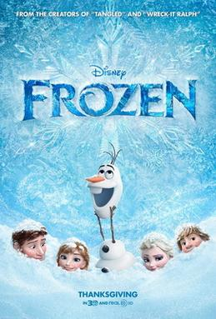
Frozen
November 27, 2013
102 mins
United States
Chris Buck
Jennifer Lee
Kristen Bell
Idina Menzel
Jonathan Groff
Josh Gad
Cartoon
189sek
When the newly crowned Queen Elsa accidentally uses her power to turn things into ice to curse her home in infinite winter, her sister, Anna, teams up with a mountain man, his playful reindeer, and a snowman to change the weather condition.

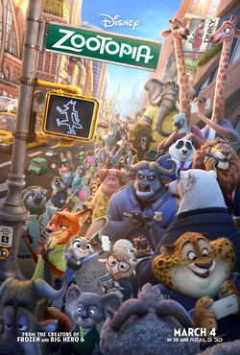
Zootopia
March 4, 2016
108 mins
United States
Byron Howard
Rich Moore
Ginnifer Goodwin
Jason Bateman
Idris Elba
J.K. Simmons
Cartoon Comedy
199sek

In a city of anthropomorphic animals, a rookie bunny cop and a cynical con artist fox must work together to uncover a conspiracy.
Big Hero 6
November 7, 2014
102 mins
United States
Canada
Don Hall
Chris Williams
Ryan Potter
Scott Adsit
Daniel Henney
T. J. Miller
Cartoon Comedy
219sek
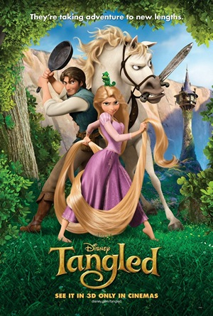
The special bond that develops between plus-sized inflatable robot Baymax, and prodigy Hiro Hamada, who team up with a group of friends to form a band of high-tech heroes.
Tangled
November 24, 2010
100 mins
United States
Nathan Greno
Byron Howard
Mandy Moore
Zachary Levi
Donna Murphy
Cartoon
Comedy
229sek
The magically long-haired Rapunzel has spent her entire life in a tower, but now that a runaway thief has stumbled upon her, she is about to discover the world for the first time, and who she really is.

The Garden of Words
May 31, 2013
46 mins
Japan
Makoto Shinkai
Miyu Irino
Kana Hanazawa
Fumi Hirano
Takeshi Maeda
Cartoon Romance 189sek
A 15-year-old boy and 27-year-old woman find an unlikely friendship one rainy day in the Shinjuku Gyoen National Garden. These two broken pieces come together and heal one another as they learn what it is to walk.
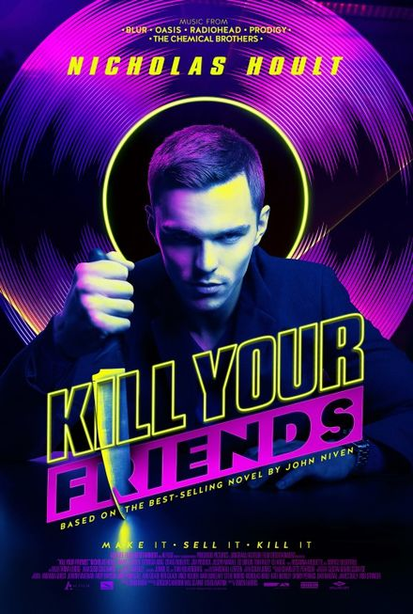
Kill Your Friends
April 1, 2016
103 mins
United Kingdom
Owen Harris
Nicholas Hoult
James Corden
Georgia King
Craig Roberts
Comedy
Crime
129sek
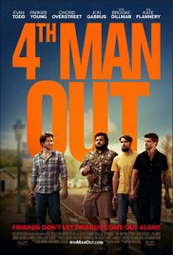
An A&R man working at the height of the Britpop music craze goes to extremes in order to find his next hit.
4th Man Out
5 February 2016
86 mins
United States
Andrew Nackman
Parker Young
Evan Todd
Chord Overstreet
Jon Gabrus
Comedy
Drama
139sek
A car mechanic in a small, working class town comes out of the closet to his unsuspecting, blue-collar best friends.

Pixels
July 24, 2015
106 mins
United States
Chris Columbus
Adam Sandler
Kevin James
Michelle Monaghan
Peter Dinklage
Comedy
Action
129sek
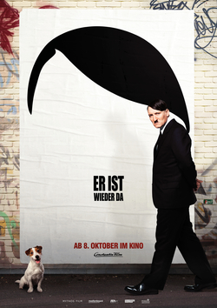
When aliens misinterpret video feeds of classic arcade games as a declaration of war, they attack the Earth in the form of the video games.
Look Who's Back
October 8, 2015
116 mins
Germany
David Wnendt
Oliver Masucci
Fabian Busch
Katja Riemann
Christoph Maria Herbst
Comedy
199sek
Adolf Hitler wakes up to find himself in the 21st century. From there he pursues a career as a standup comedian.

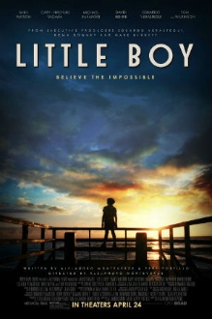
Little Boy
April 24, 2015
107 mins
United States
Mexico
Alejandro Monteverde
Jakob Salvati
Emily Watson
Cary-Hiroyuki Tagawa
Michael Rapaport
Comedy
Drama
199sek
An eight-year-old boy is willing to do whatever it takes to end World War II so he can bring his father home. The story reveals the indescribable love a father has for his little boy and the love a son has for his father.

The Man from U.N.C.L.E.
August 14, 2015
116 mins
United States
Guy Ritchie
Henry Cavill
Armie Hammer
Alicia Vikander
Elizabeth Debicki
Comedy
Crime Action
129sek
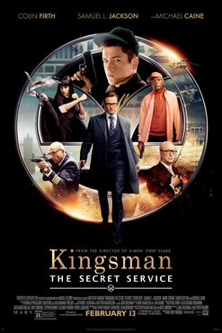
In the early 1960s, CIA agent Napoleon Solo and KGB operative Illya Kuryakin participate in a joint mission against a mysterious criminal organization, which is working to proliferate nuclear weapons.
Kingsman: The Secret Service
13 February 2015
129 mins
United Kingdom
United States
Matthew Vaughn
Colin Firth
Samuel L. Jackson
Mark Strong
Taron Egerton
Comedy
Crime Action 99sek
A spy organization recruits an unrefined, but promising street kid into the agency's ultra-competitive training program, just as a global threat emerges from a twisted tech genius.
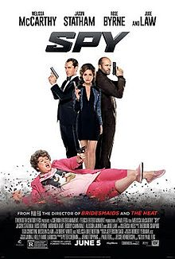
Spy
June 5, 2015
120 mins
United States
Paul Feig
Melissa McCarthy
Jason Statham
Rose Byrne
Miranda Hart
Comedy Crime Action
99sek
A desk-bound CIA analyst volunteers to go undercover to infiltrate the world of a deadly arms dealer, and prevent diabolical global disaster.
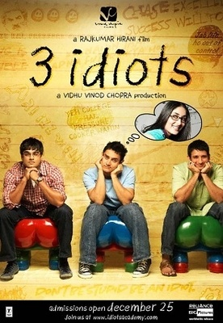
3 Idiots
25 December 2009
171 mins
India
Rajkumar Hirani
Aamir Khan
Madhavan
Sharman Joshi
Kareena Kapoor Khan
Comedy Drama Romance
59sek
Two friends are searching for their long lost companion. They revisit their college days and recall the memories of their friend who inspired them to think differently, even as the rest of the world called them “idiots".
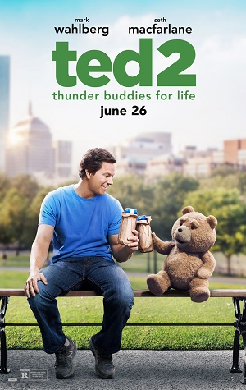
Ted 2
June 26, 2015
115 mins
United States
Seth MacFarlane
Mark Wahlberg
Seth MacFarlane
Amanda Seyfried
Giovanni Ribisi
Comedy
129sek
Newlywed couple Ted and Tami-Lynn want to have a baby, but in order to qualify to be a parent, Ted will have to prove he's a person in a court of law.
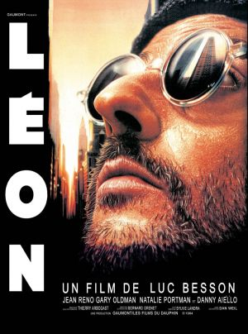
Léon: The Professional
14 September 1994
133 mins
France
Luc Besson
Jean Reno
Gary Oldman
Natalie Portman
Danny Aiello
Crime
Action Drama Romance
99sek
Mathilda, a 12-year-old girl, is reluctantly taken in by Léon, a professional assassin, after her family is murdered. Léon and Mathilda form an unusual relationship, as she becomes his protégée and learns the assassin's trade.

Furious 7
April 3, 2015
137 mins
United States
James Wan
Vin Diesel
Paul Walker
Dwayne Johnson
Michelle Rodriguez
Crime
Action
99sek
Deckard Shaw seeks revenge against Dominic Toretto and his family for his comatose brother.

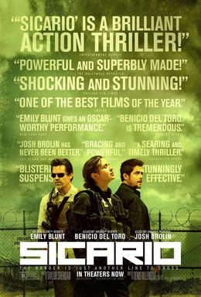
Sicario
September 18, 2015
121 mins
United States
Denis Villeneuve
Emily Blunt
Benicio del Toro
Josh Brolin
Victor Garber
Crime
Drama
Action
149sek
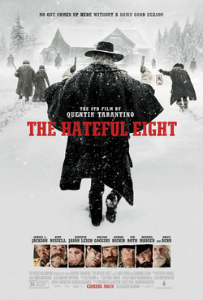
An idealistic FBI agent is enlisted by a government task force to aid in the escalating war against drugs at the border area between the U.S. and Mexico.
The Hateful Eight
December 25, 2015
168 mins
United States
Quentin Tarantino
Samuel L. Jackson
Kurt Russell
Jennifer Jason Leigh
Walton Goggins
Crime
Comedy
Drama
149sek
In the dead of a Wyoming winter, a bounty hunter and his prisoner find shelter in a cabin currently inhabited by a collection of nefarious characters.
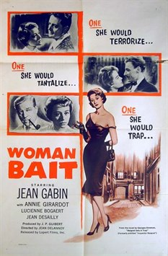
Maigret Sets a Trap
29 January 1958
119 mins
France
Italy
Jean Delannoy
Jean Gabin
Annie Girardot
Olivier Hussenot
Jeanne Boitel
Crime Drama
99sek
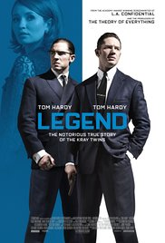
Chief Inspector Jules Maigret hunts for a serial killer.
Legend
9 September 2015
131 mins
United Kingdom
Brian Helgeland
Tom Hardy
Emily Browning
David Thewlis
Duffy
Crime Drama Action
149sek
The film tells the story of the identical twin gangsters Reggie and Ronnie Kray, two of the most notorious criminals in British history, and their organised crime empire in the East End of London during the 1960s.
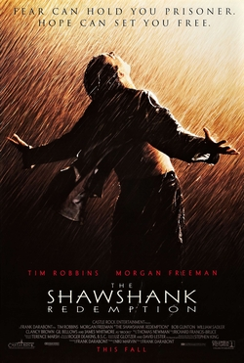
The Shawshank Redemption
September 23, 1994
142 mins
United States
Frank Darabont
Tim Robbins
Morgan Freeman
Bob Gunton
William Sadler
Crime
Crime
Drama
49sek
Two imprisoned men bond over a number of years, finding solace and eventual redemption through acts of common decency.
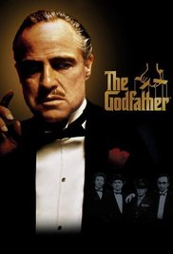
The Godfather
March 24, 1972
175 mins
United States
Francis Ford Coppola
Marlon Brando
Al Pacino
James Caan
Richard Castellano
Crime Drama
59sek
The aging patriarch of an organized crime dynasty transfers control of his clandestine empire to his reluctant son.
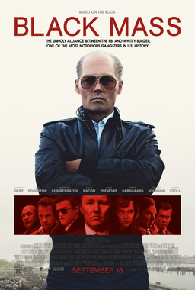
Black Mass
September 18, 2015
122 mins
United States
Scott Cooper
Johnny Depp
Joel Edgerton
Benedict Cumberbatch
Rory Cochrane
Crime
Drama
189sek

The true story of Whitey Bulger, the brother of a state senator and the most infamous violent criminal in the history of South Boston, who became an FBI informant to take down a Mafia family invading his turf.
Victoria
11 June 2015
138 mins
Germany
Sebastian Schipper
Laia Costa
Frederick Lau
Franz Rogowski
Crime
Drama
139sek
A young Spanish woman who has newly moved to Berlin finds her flirtation with a local guy turn potentially deadly as their night out with his friends reveals a dangerous secret.

